File System

Chad Weirick

Grand Canyon University: CST-221

6-28-19

**Abstract**

This paper will cover the questions regarding the file system of a typical Linux distribution. In particular, Unbuntu 18.04 was used for gathering data for this assignment.

**Directory Overview**

See the table for a purpose of the different directories:

|  |  |
| --- | --- |
| **Directory** | **Purpose** |
| / | This is the root folder. It contains all of the other folders listed here. |
| /bin | Bin is short for binaries. This folder keeps all of the required user binary files. |
| /dev | While it might sound like a developer folder, this is actually the device folder. This folder acts as a home for representatives of devices that appear as folders here. For example, a USB drive would appear here. |
| /etc | System configuration files are stored in the /etc. |
| /lib | /lib stands for Library. Shared library files are stored here. |
| /boot | The boot folder contains all of the static boot files needed to load the OS. |
| /home | For anyone who has used Windows, this is the rough analog of the Windows Users folder. The /home directory contains documents, downloads, and other files pertaining to each user. |
| /mnt | /mnt stands for Mount. This is where temporary mount points are stored. |
| /proc | /proc stands for Process or Process Files depending on the source. Process and kernel files belong here. |
| /tmp | /tmp stands for Temp or Temporary. Temporary files are stored here, not dissimilar to how Windows treats its own temp folder. |
| /usr | /usr stands for User. While it might be tempting to think that this is the analog of the Windows users folder, it is actually where user-specific binaries are stored. Read only data might be stored here as well. |
| /var | /var stands for Variable data files. This is often used for logging. |
| /sbin | /sbin is the home of system binaries. Similar to /bin, these are intended to be run only by the root user in most cases. |
| /kernel | I do not have a /kernel folder, but I believe it to be similar to the /proc folder. |

**Directories Under Root**

In addition to the items listed above, here are additional folders and their purpose. See the table for a purpose of the different directories:

|  |  |
| --- | --- |
| **Directory** | **Purpose** |
| /cdrom | Some Linux distros, especially relatively new Unbuntu distros, will have this. It is to serve as a temporary location for optical media prior to it being available in the /media folder. |
| /run | My research indicates that this is a companion to the /var/run. It is used as a temporary mount point during boot. |
| /lib64 | A 64 bit version of the /lib folder. |
| /opt | This is used for optional packages managed by a package manager in Unbuntu. |
| /media | The /media folder is where optical drives get mounted. Other formats such as disk drives, ZIP drives, etc. might also end up here. |
| /snap | This is a where the unbuntu package manager installs snap packages to. |
| /srv | The /srv folder stands for Serve folder. It hosts protocol-specific data such as ftp/smb, etc. |
| /sys | Used as a virtual file system folder to assist in addressing other devices attached to the system. |

**Compiling Flow Chart**

Here is a link to the C compilation flowchart to support the scenario given. Unfortunately, due to the size and shape, it does not display well inside of word. It is included as an attachment for the sake of clarity and convenience. The additional flowchart is included here:

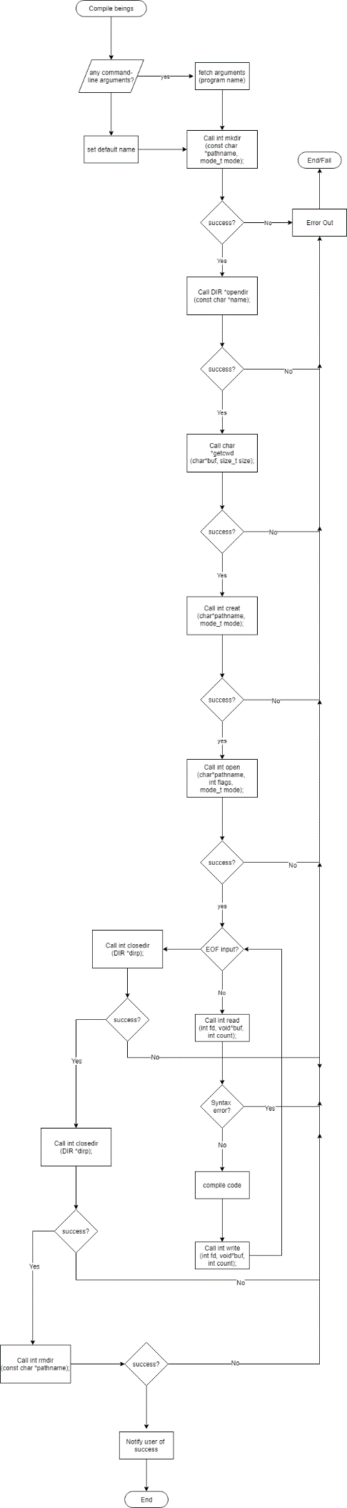

**Scripts and GitHub Link**

Section 5 requests links to bash scripts, but none were requested by the instructions here and thus none were made/developed. The GitHub link is: https://github.com/chadatgcu/cst221.git and then access the week 6 folder.